Account creation - https://account.hana.ondemand.com/#/home/welcome

Subaccount would be created with dev space - subscribed to BAS
Create subscription to HANA cloud by creating an instance

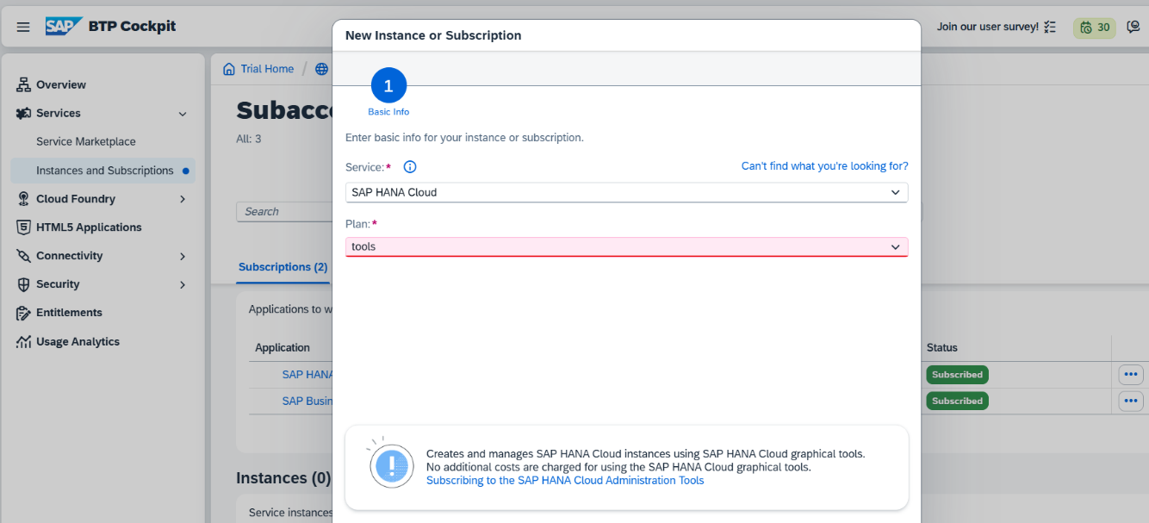

Once created, assign roles
Security -> Users -> Role collections and add HANA cloud administrator role

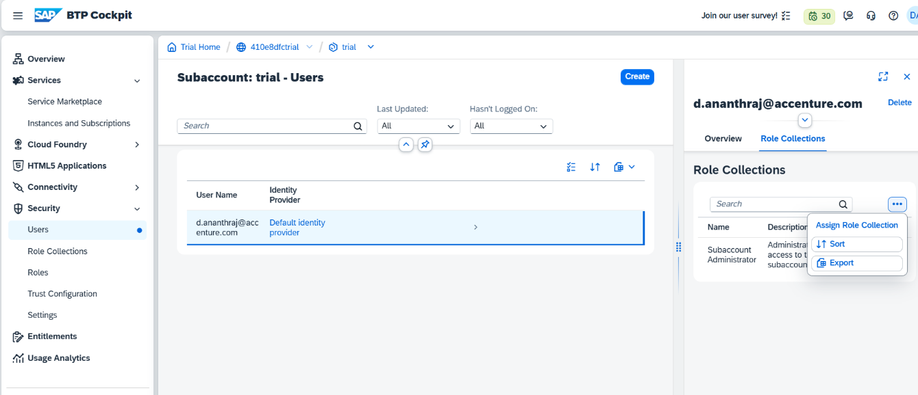

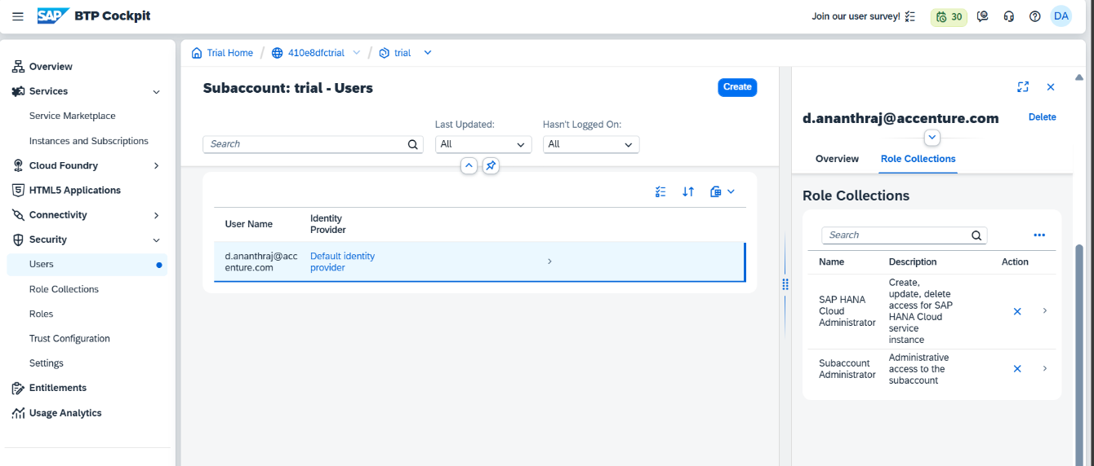

Once added, navigate to Hana cloud instance to create a DB

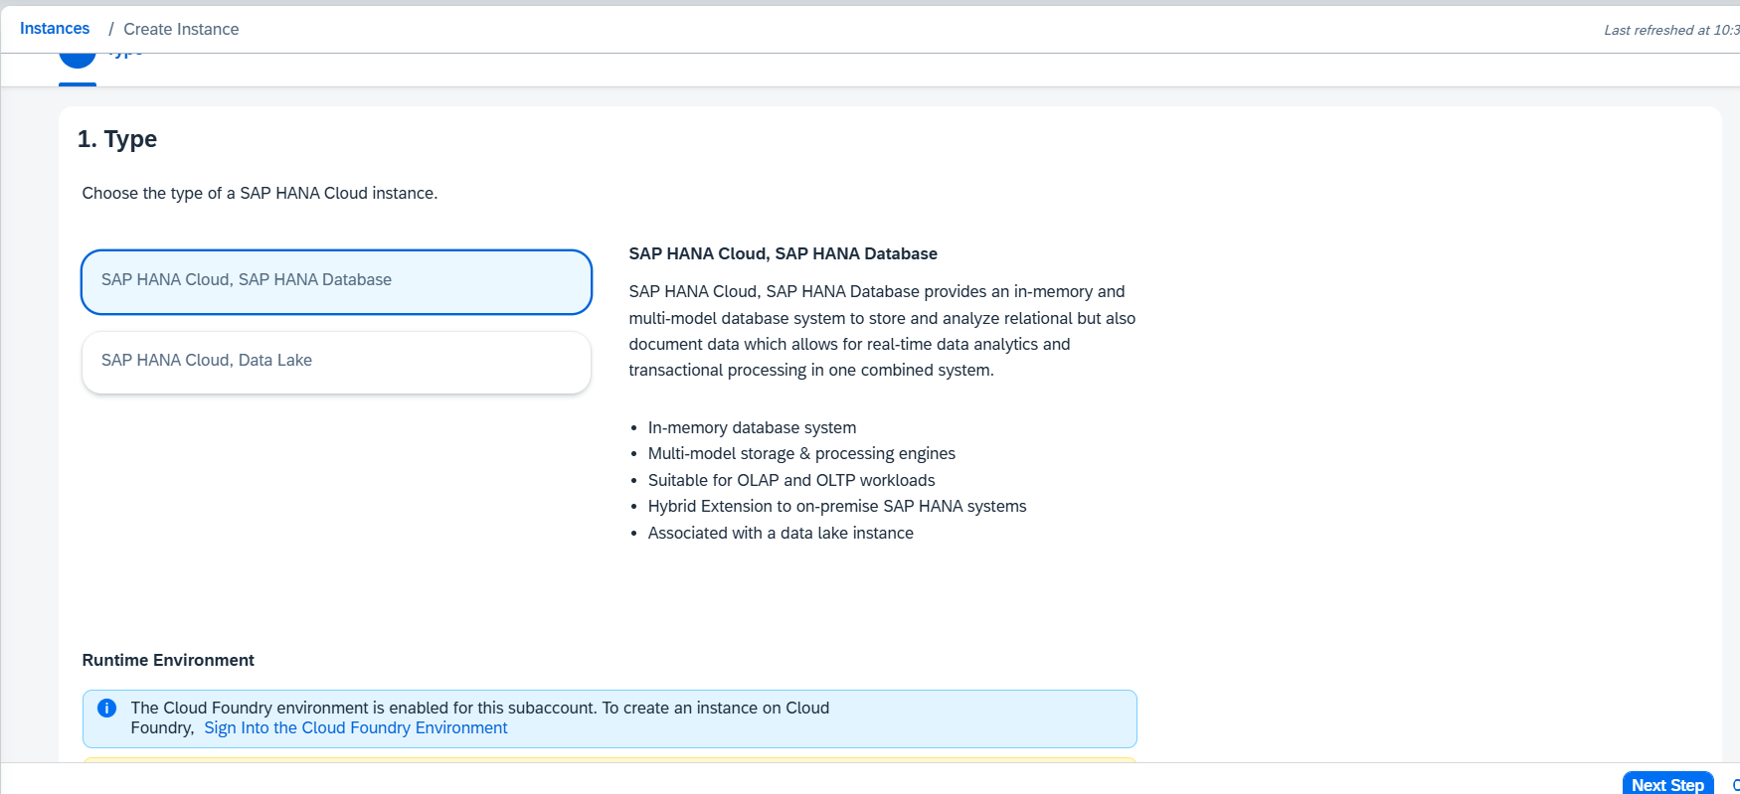

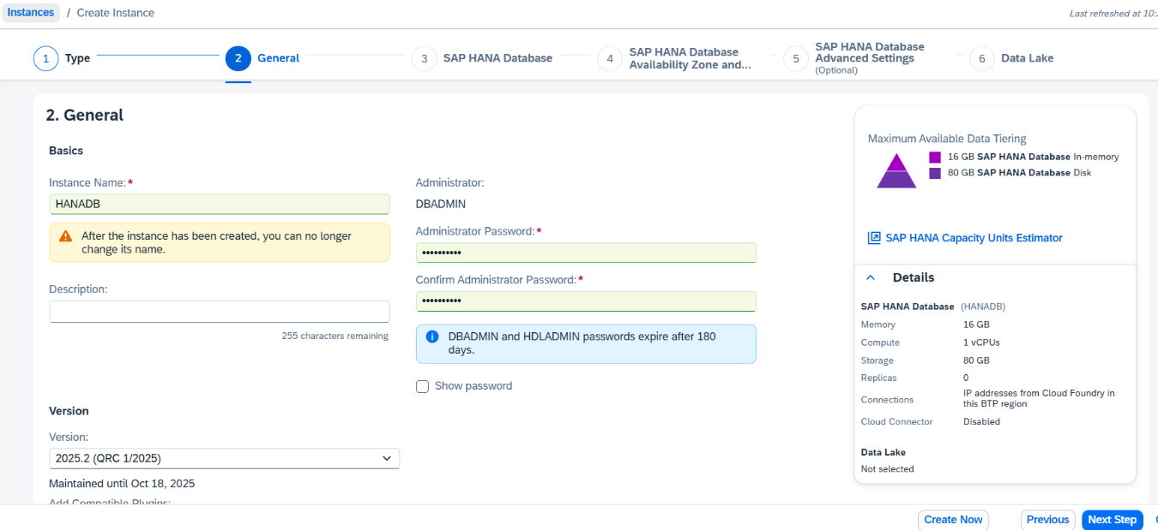

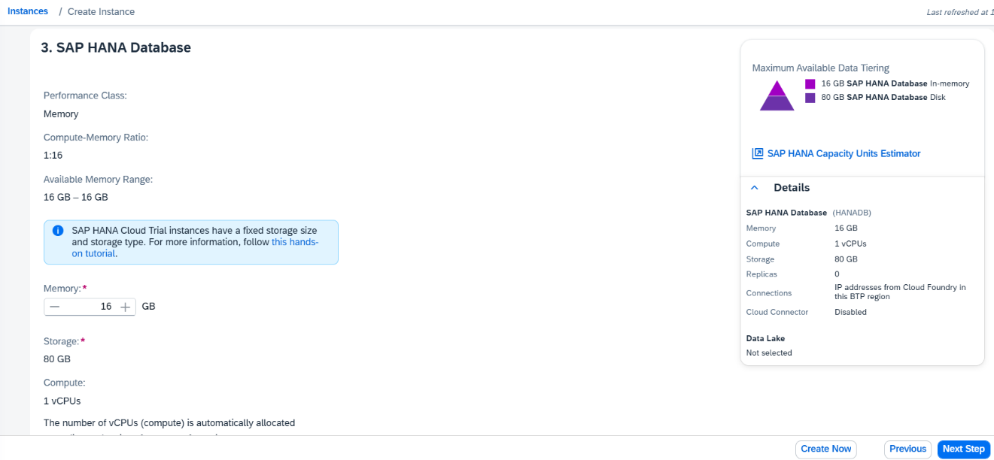

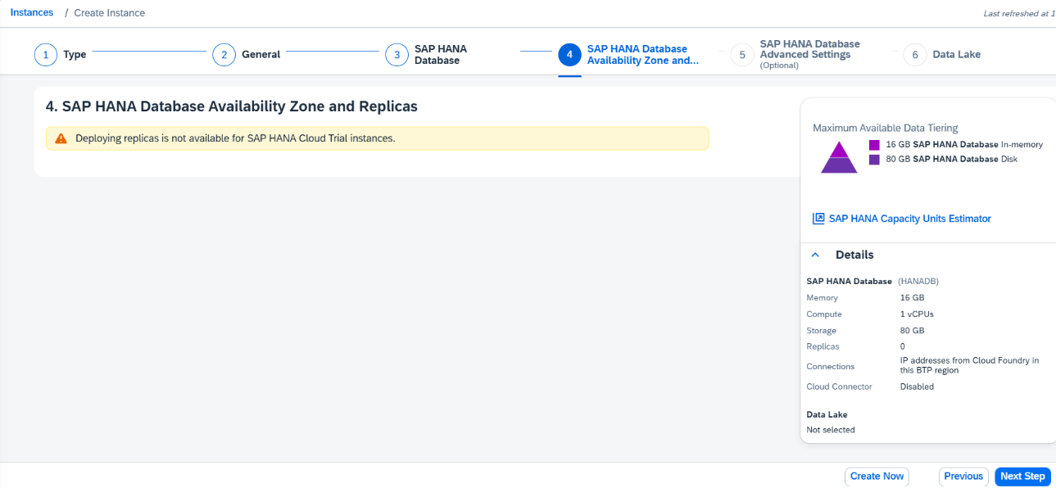

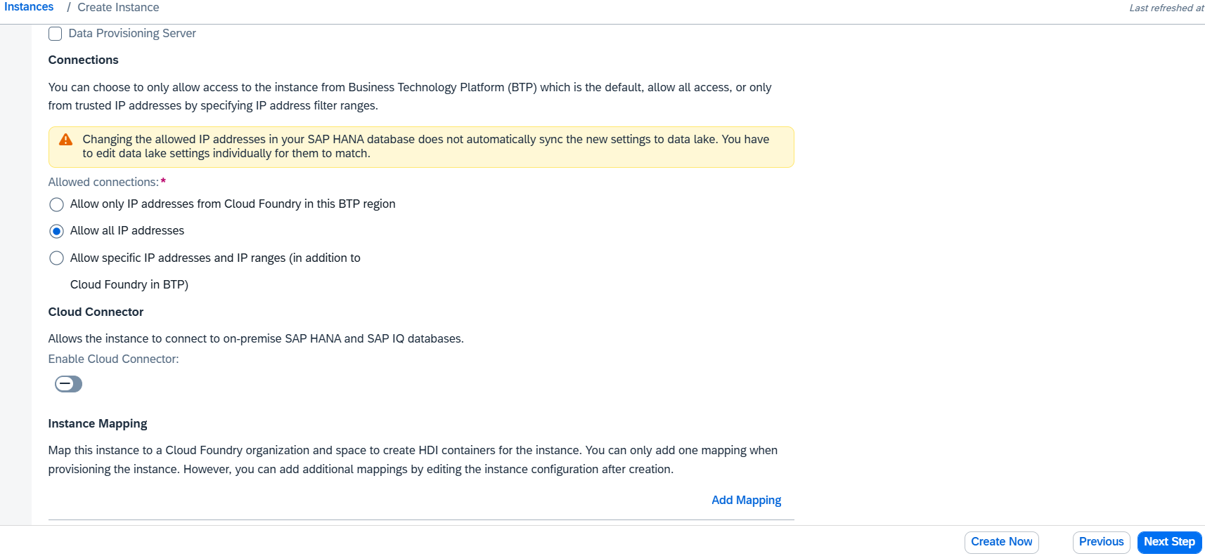

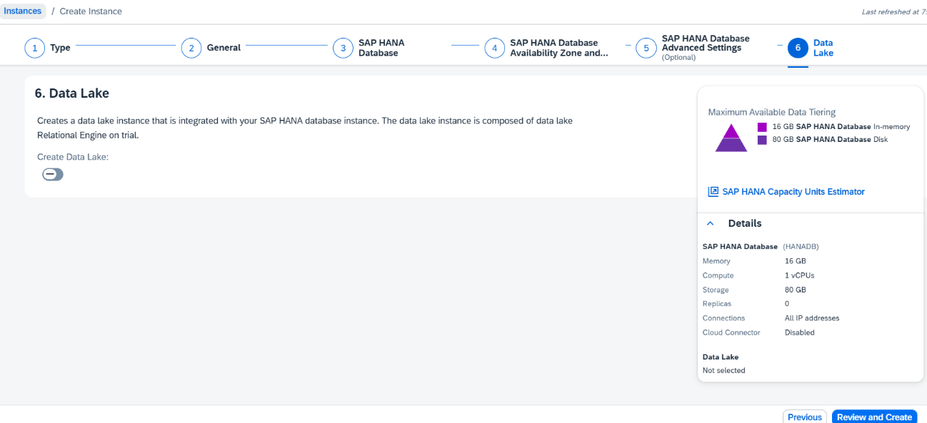

Once instance is created, access HANA DB

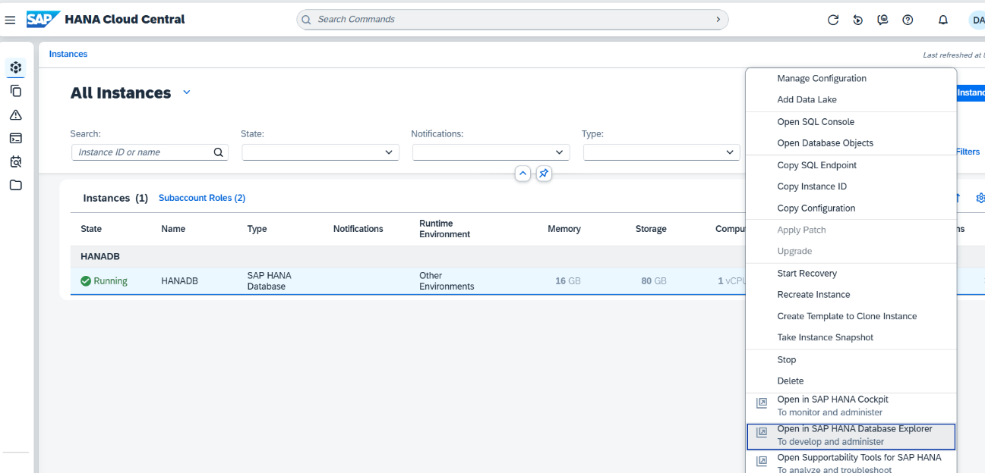

Enter the DBADMIN as user name and password that has been created

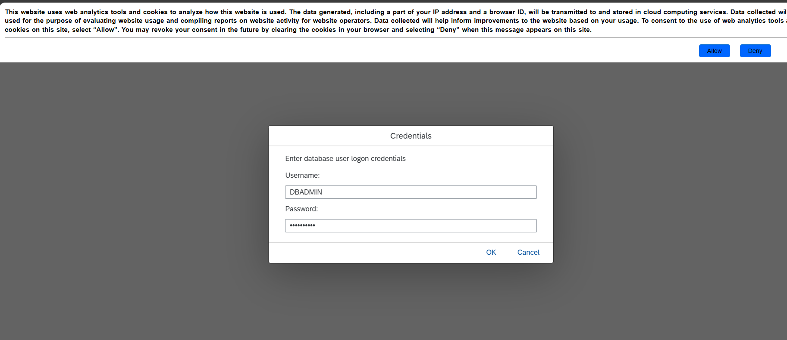

Entitlements - can add services from here

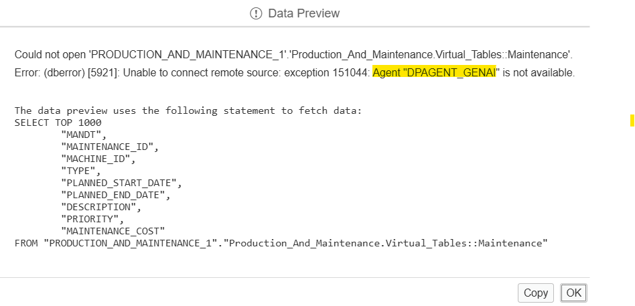

Queires:
Delete:

delete from ROYALITY_ENQUIRY_1."Royality_Enquiry.Tables::OIU_DO_DO" where COMPANY_CODE is null;

Timestamp conversion:

SELECT
TO_TIMESTAMP('10.08.2023 05:42:37', 'DD.MM.YYYY HH24:MI:SS') AS timestamp_value_1
FROM DUMMY;

YYYY-MM-DD HH:MM:SS.FFF

Exponential into number:

SELECT TO_DECIMAL('1.50000000000000E+01') AS converted_number FROM DUMMY;

Convert date YYYY-MM-DD

Do not update data with "," separator for numeric columns

Schema to schema import:

insert into <schema1>.<Table> values( select * from <schema2>.<Table>)

export the data from the tables and import in the tables of other scehma

Null to blank records:

UPDATE CUSTOMERS
SET EMAIL = ''
WHERE EMAIL IS NULL;

This only works on columns with VARCHAR, NVARCHAR, or CHAR data types.

Timestamp conversion:

CREATE TABLE TEMP_TIMESTAMP_UPLOAD (
RAW_TEXT NVARCHAR(30)
);

Upload data

SELECT
RAW_TEXT,
TO_TIMESTAMP(RAW_TEXT, 'DD.MM.YYYY HH24:MI:SS') AS CONVERTED_TIMESTAMP
FROM TEMP_TIMESTAMP_UPLOAD;

Delete from TEMP_TIMESTAMP_UPLOAD;

DROP TABLE TEMP_TIMESTAMP_UPLOAD;

YYYY-MM-DD HH:MM:SS

Vector DB Table:

Vector embedding is defined from python side and table will be automatically created

CREATE COLUMN TABLE "HC1_DB_CONNECTOR"."Presales"(
"VEC_TEXT" NCLOB MEMORY THRESHOLD 1000,
"VEC_META" NCLOB MEMORY THRESHOLD 1000,
"VEC_VECTOR" REAL_VECTOR
)
UNLOAD PRIORITY 5 AUTO MERGE;

Not blank:

select * from PRODUCTION_AND_MAINTENANCE_1."Production_And_Maintenance.Virtual_Tables::Maintenance" where MACHINE_ID != ' ' and priority != ' ';

Session memory tables:

CREATE COLUMN TABLE HC1_DB_CONNECTOR.CHAT_SESSION_HISTORY (
"USECASEID" NVARCHAR(225),
"USER_ID" NVARCHAR(255),
"SESSION_ID" NVARCHAR(36),
"LABEL" NVARCHAR(255),
"START_DATE_TIME" TIMESTAMP,
"LAST_MESSAGE" TIMESTAMP
);

CREATE COLUMN TABLE HC1_DB_CONNECTOR.SESSION_CONVERSATION (
"ID" NVARCHAR(36),
"SESSION_ID" NVARCHAR(36),
"SOURCE" NVARCHAR(50),
"MESSAGE" BLOB,
"POSTDATE" TIMESTAMP NOT NULL
)

Insert from one table to another
INSERT INTO "MYSCHEMA"."TARGET_TABLE"
SELECT * FROM "MYSCHEMA"."SOURCE_TABLE";

SQL Script:

books_per_publisher = SELECT publisher, COUNT (*) AS num_books FROM BOOKS GROUP BY publisher;
publisher_with_most_books = SELECT * FROM :books_per_publisher WHERE num_books >= (SELECT MAX (num_books) FROM :books_per_publisher);

It is possible to identify how many queries were not unfolded. Run a query on system view M_FEATURE_USAGE as follows:

SELECT
FEATURE_NAME,
CALL_COUNT
FROM
"M_FEATURE_USAGE"
WHERE
COMPONENT_NAME = 'CALCENGINE'
AND
FEATURE_NAME
IN
('QUERY TOTAL','QUERY UNFOLDING')

ALTER TABLE

ALTER TABLE SESSION_CONVERSATION ADD (MESSAGE_SOURCE NVARCHAR(50));

UPDATE SESSION_CONVERSATION SET MESSAGE_SOURCE = SOURCE;

ALTER TABLE SESSION_CONVERSATION DROP (SOURCE);

BLOB TO STRING

SELECT message_sources, CAST(BONTOSTR(CAST(message AS BINARY)) AS VARCHAR) as message, postdate
FROM table

MDS CUBE:

{
"Cube": {
"Command": "Reload",
"Target": {
"DataSource": {
"SchemaName": "<Schema>",
"ObjectName": "<MDS Cube Name>"
}
}
}
}

CREATE TABLE TRS_GROWTH (
COMPANY_NAME NVARCHAR(250),
FIVE_YEAR_TRS_CAGR INTEGER,
THREE_YEAR_TRS_CAGR INTEGER,
ONE_YEAR_TRS_CAGR INTEGER,
SNAPSHOT_DATE DATE,
EVAL_COMP_COMPANY NVARCHAR(5)
);

DROP TABLE TRS_GROWTH;

DELETE FROM TRS_GROWTH;

ALTER TABLE HC1_DB_CONNECTOR.TRS_GROWTH
RENAME COLUMN FIVE_YEAR_TRS_CAGR TO FIVEYEAR_TRS_CAGR_PERCENT;

ALTER TABLE HC1_DB_CONNECTOR.TRS_GROWTH
ALTER (ONE_YEAR_TRS_CAGR DECIMAL(5,1));

CREATE TABLE EVIC_DECOMPOSITION (
COMPANY_NAME NVARCHAR(250),
ENTERPRISE_VALUE INTEGER,
INVESTED_CAPITAL INTEGER,
EBIT INTEGER,
EV_IC DECIMAL(5,2),
EV_EBIT DECIMAL(5,2),
SNAPSHOT_DATE DATE,
EVAL_COMP_COMPANY NVARCHAR(5)
);

DELETE FROM EVIC_DECOMPOSITION;

CREATE TABLE REVENUE_PROFIT_ESTIMATE (
ESTIMATE NVARCHAR(100),
UNILEVER_PLC_2025E DECIMAL(5,1),
PEER_MEDIAN_2025E DECIMAL(5,1),
UNILEVER_PLC_2026E DECIMAL(5,1),
PEER_MEDIAN_2026E DECIMAL(5,1),
UNILEVER_PLC_2027E DECIMAL(5,1),
PEER_MEDIAN_2027E DECIMAL(5,1)
)

DROP TABLE HC1_DB_CONNECTOR.REVENUE_GROWTH

ALTER TABLE HC1_DB_CONNECTOR.REVENUE_GROWTH
ADD (EVAL_COMP_COMPANY NVARCHAR(5));

ALTER TABLE HC1_DB_CONNECTOR.REVENUE_GROWTH
ADD (SNAPSHOT_DATE DATE);

ALTER TABLE HC1_DB_CONNECTOR.CASH_CYCLE
ADD (SNAPSHOT_DATE DATE);

DROP TABLE HC1_DB_CONNECTOR.PRE_TAX;

ALTER TABLE HC1_DB_CONNECTOR.PRE_TAX DROP (CAPITAL_EFFICIENCY_2024);

ALTER TABLE HC1_DB_CONNECTOR.PRE_TAX
ADD (NET_OTHER_OPERATING_2022% DECIMAL(5,1));

MERGE INTO SAP_AI_CTR.RULE_BASED_STG AS t
USING CV_CONTRACTS AS s
ON t.AGREEMENT_CODE = s.AGREEMENT_CODE
WHEN MATCHED THEN
UPDATE SET t.PRIM_HASHKEY = s.PRIM_HASHKEY;

SELECT
TABLE_NAME,
RECORD_COUNT,
MEMORY_SIZE_IN_TOTAL
FROM M_CS_TABLES
WHERE SCHEMA_NAME = 'SAP_AI_CTR';

Git
1] Select the branch from bas
2] Form git -> branch -> merge
3] Conflict

Git rebase

git stash
git pull
git stash pop

CID : C09044041
EID: 13948362

SAP S ID : S0026709897
S0027584560
Dhatshayani1
P2012900774
Dhatshayani
Ananth

Password : Dwitch@111
Partner ID: 0000635562

SAP Trail
reyshwa@gamil.com
Dwitch@111

SAP HANA cloud

Developing Data Models with SAP HANA Cloud | SAP Learning
Getting Started with Multitarget Application Development in Cloud Foundry on SAP BTP | SAP Help Portal
Getting Started With Native SAP HANA Development i... - SAP Community
New Calculation View Modeling Features in SAP HANA... - SAP Community
FAQ Modeling HANA Calculation Views in SAP Busines... - SAP Community
Best Practice collection working with Business App... - SAP Community

Get an Account on SAP BTP Trial | SAP Tutorials

Free SAP HANA Cloud Trial – How to set it up / reg... - SAP Community

Start Using SAP HANA Cloud Trial in SAP BTP Cockpit | SAP Tutorials

Home | capire

Microlearning on SAP HANA Cloud : https://microlearning.opensap.com/category/SAP+HANA+Cloud/213247923

SAP HANA Views : https://learning.sap.com/courses/working-with-calculation-views-in-sap-hana-cloud

Working with Test Data | SAP Help Portal

